ONLINE VOTING SYSTEM

S.No Name page No

1. Aim 3

2. Abstract 3

3. Introduction 3

4. Existing System 4

5. Proposed System 4

6. Requirement 5

7. Modules 5

8. TestPlan 6

9. Diagram 6

10. Implementation 8

11. Output 13

12. Future Enchancement 14

13. Conclusion 15

1.Aim:

The specific objectives of the project is:

* Reviewing the current voting system.
* Implementing a automated/online voting system.
* Error free of counting of polled votes.
* No problem will occur while voting.

2.Abstract:

The word “vote” means to choose from a list,to elect or to determine. The main goal of voting(in a scenario involving the voter of a given college) is to come up with leaders of the people’s choice. Some of the problem involved include ridging votes during the election,insecure or inaccessible polling station,inadequate polling materials and also inexperienced personnel.

The online voting seeks to address the above issues.It should be noted that with the sytem in place,voters in this case shall be given example time during the voting period.

3.Introduction:

“ONLINE VOTING SYSTEM ” is an online voting techniques.In this system people who have Id card and some eligiblility criteria they can give their vote online without going to any physical station.There is a database which is maintained in a which all the names of voters with complete information is stored.

In “ONLINE VOTING SYSTEM” a voter can use their voting right online without any difficulty.Registration is mainly done by the administrator for a security reason. The system administrator register the vote on a special site of the system visited only by simply filling a registration from to register voter.

After register,the voter is assigned a scecret voter Id with which use to log into the system administration and enjoy the services.

There are four operations are doing here ,cast the vote,fint the vote count and find the leading voted candidate and vote. These are the operation of the system.

4. Existing system:

The problem of the existing manual system of voting include the among others the followings are,\

* Expensive and Time consuming
* Too much paper work
* Error during data entry
* Loss of registration form
* Short time
* Too much cost

5.Proposed System:

The project is related to the Online voting system.

It providing a proper management

Advantages:

* Planned approach towards working.
* Reliablility.
* No Redundancy.
* Accurancy.
* Easy to operate.
* Immediate storage of information.

6.Required Specification:

Software Requirement:

* OS(windows/Linux)
* Command promt
* Visual studio code
* Git
* Note pad
* Ms word
* C compiler

Hardware Requirements:

* Windows 10
* Min 4gb Ram
* Memory 1tb
* Processor i3

7.Modules:

1.Login

2.Vote

3.Vote count

4.Leading candidate.

8. TestPlan

High Level test:

| **ID** | **Description** | **Result** |
| --- | --- | --- |
| HLT1 | Required Inputs is given | pass |
| HLT2 | The components are given required to the system | pass |
| HLT3 | Sample input is given | pass |

Low Level Test:

| **ID** | **Description** | **Results** |
| --- | --- | --- |
| LLT1 | Adding details of voter id | pass |
| LLT2 | Find the cast vote | pass |
| LLT3 | adding the voting count | pass |
| LLT4 | Find the leading candiate | pass |
|  |  |  |

9. Diagram:

Flowchart Diagram:

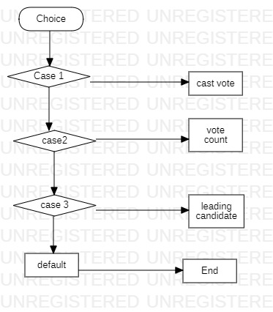

Usecase Diagram:

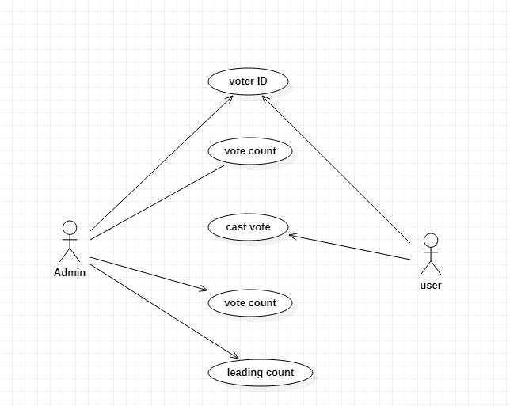

10. Implementation:

#include <stdio.h>

#include <stdlib.h>

// define macroname charseq

// total no of the parties

#define total_no_of_parties

#define party_no_1 "A"

#define party_no_2 "B"

#define party_no_3 "C"

#define party_no_4 "D"

int vote_Count1 = 0,

vote_Count2 = 0,

vote_Count3 = 0,

vote_Count4 = 0,

invalid_votes = 0;

void castVote(){

int choice;

printf("\n \n <#> <#> <#> <#> Please chooose your Candidate <#> <#> <#> <#> \n \n");

printf("\n 1. %s", party_no_1);

printf("\n 2. %s", party_no_2);

printf("\n 3. %s", party_no_3);

printf("\n 4. %s", party_no_4);

printf("\n 5. %s", "None of the above");

printf("\n \n Input your choice ( 1 - 4 ) : ");

scanf("%d", &choice);

switch (choice){

case 1:

vote_Count1++;

break;

case 2:

vote_Count2++;

break;

case 3:

vote_Count3++;

break;

case 4:

vote_Count4++;

break;

case 5:

invalid_votes++;

break;

default:

printf(" \n Error: Wrong Chocie !! Please retry");

// built in function for holding the screen.

getchar();

}

printf(" \n Thanks for your vote !!");

}

void votesCount(){

printf("\n \n #_#_#_#_# Voting Statics #_#_#_#_#");

printf("\n %s - %d", party_no_1, vote_Count1);

printf("\n %s - %d", party_no_2, vote_Count2);

printf("\n %s - %d", party_no_3, vote_Count3);

printf("\n %s - %d", party_no_4, vote_Count4);

printf("\n %s - %d", "Spoiled Votes", invalid_votes);

}

void getLeadingCandiate(){

printf("\n \n #_#_#_#_# Leading Candiate #_#_#_#_#");

if(vote_Count1 > vote_Count2 && vote_Count1 > vote_Count3 && vote_Count1 > vote_Count4){

printf("The Leading Candiate is %s", party_no_1);

}else if(vote_Count2 > vote_Count1 && vote_Count2 > vote_Count3 && vote_Count2 > vote_Count4){

printf("The Leading Candiate is %s", party_no_2);

}else if(vote_Count3 > vote_Count2 && vote_Count3 > vote_Count1 && vote_Count3 > vote_Count4){

printf("The Leading Candiate is %s", party_no_3);

}else if(vote_Count4 > vote_Count2 && vote_Count4> vote_Count3 && vote_Count4 > vote_Count1){

printf("The Leading Candiate is %s", party_no_4);

}else {

printf("+++++++++++++ Warning!!!!!!!!! No Win-Win Situation ++++++++++++++");

}

}

int main(){

int choice;

do{

printf("\n \n #_#_#_#_#_# WELCOME TO ELECTION / VOTING 2022 #_#_#_#_#_#");

printf("\n \n 1. Cast the Vote.");

printf("\n \n 2. Find the Vote Count.");

printf("\n \n 3. Find the Leading Candidate.");

printf("\n \n 0. Exit.");

printf("\n \n Please Enter Your Choice : ");

scanf("%d", &choice);

switch(choice){

case 1:

castVote();

break;

case 2:

votesCount();

break;

case 3:

getLeadingCandiate();

break;

default:

printf("\n Error: Invalid Choice !!!");

}

} while (choice!=0);

getchar();

}

11.Output:

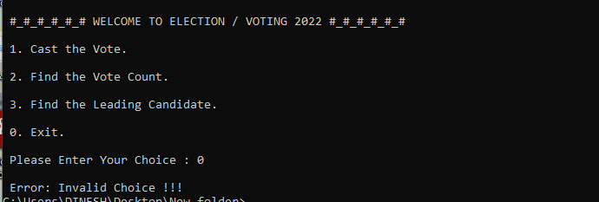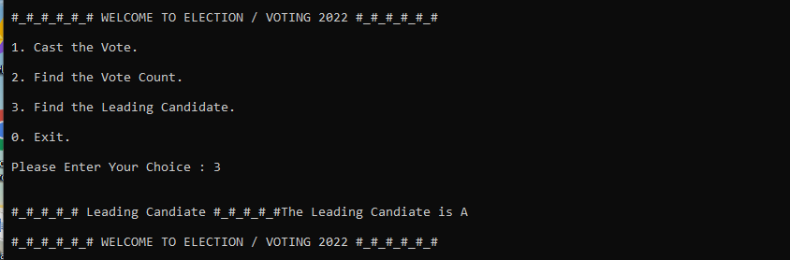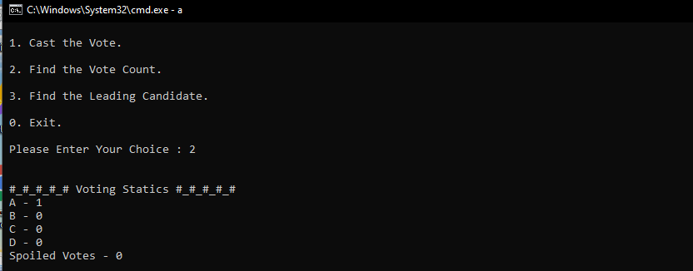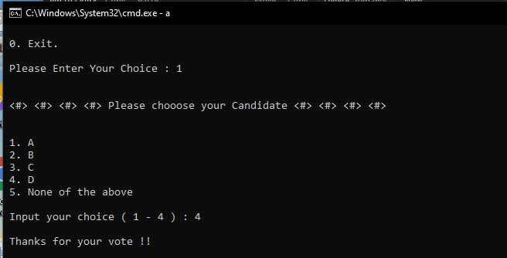

12.Future Enchancement:

The online Voting system platform can be more secure by the following methods in the future.

1.Password

2.Fingerprinting

3.Camera

13.Conclusion:

This Online Voting System will manage the voters information by which voter can login and use his voting rights. The systems will incorporate all the features of voting system.It is very useful for the small voting election conducted by the college,school,institutions and some committees.